April DEAM Calendar (Drop Everything and Move)
Every day in April, perform or complete the activity of the day. Have a family member sign off on it. It is not a requirement to return this to me, however, if you’d like to share it with me, I would love to hear from you!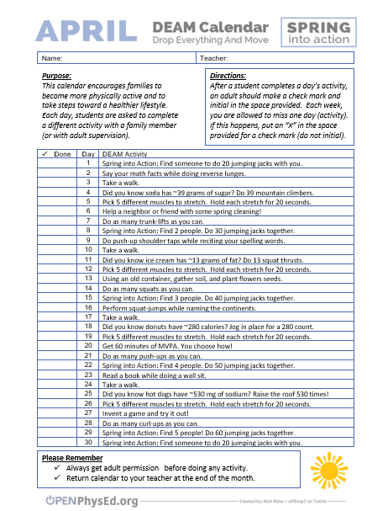

Boot Camp #1 and #2
Perform each activity listed for 30 seconds.

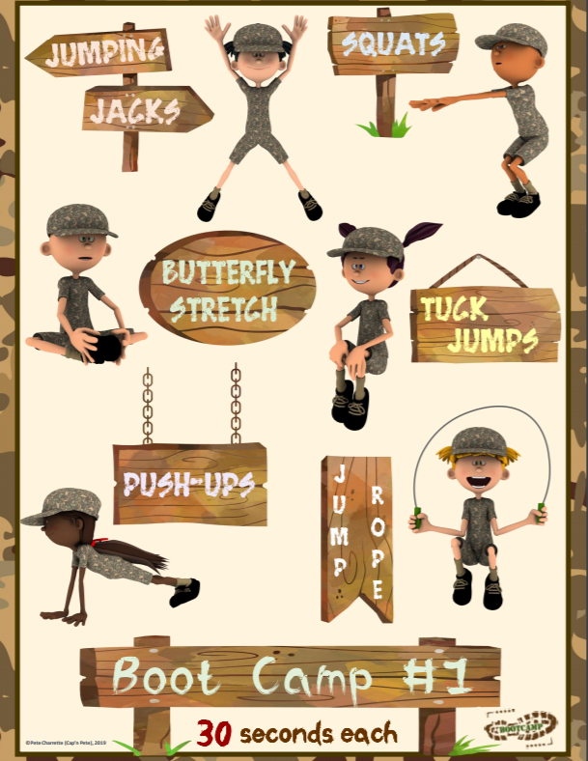

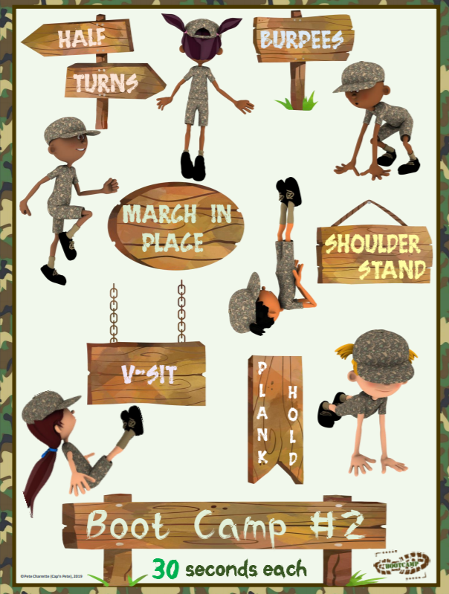

Tabata #1 and #2
Perform the activity for 20 seconds, take a 10 second rest. Repeat until you’ve performed all the activities.

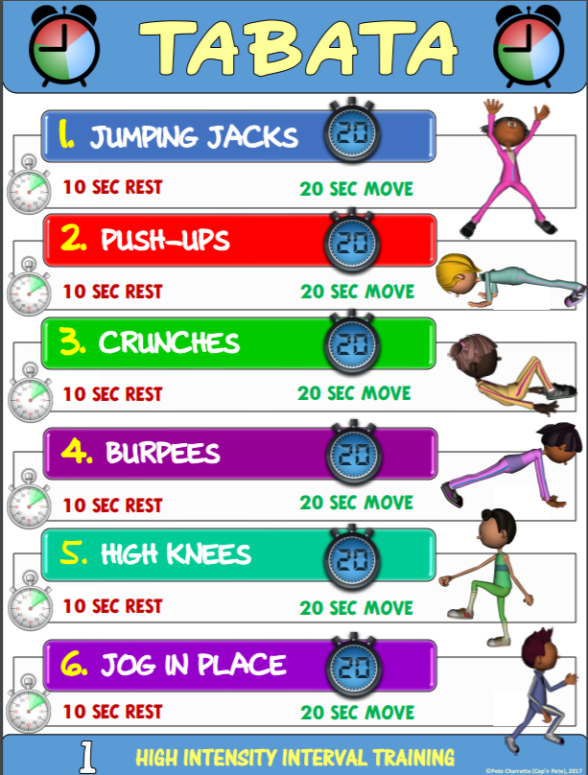

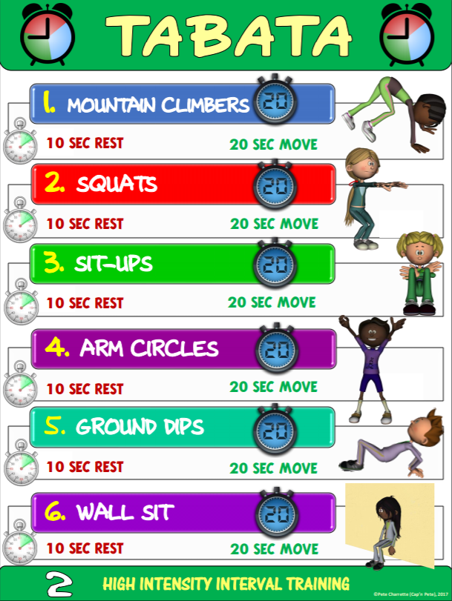

As Many Rounds As Possible (AMRAP)
Perform each activity for the number of repetitions listed. Complete as many cycles as you can.

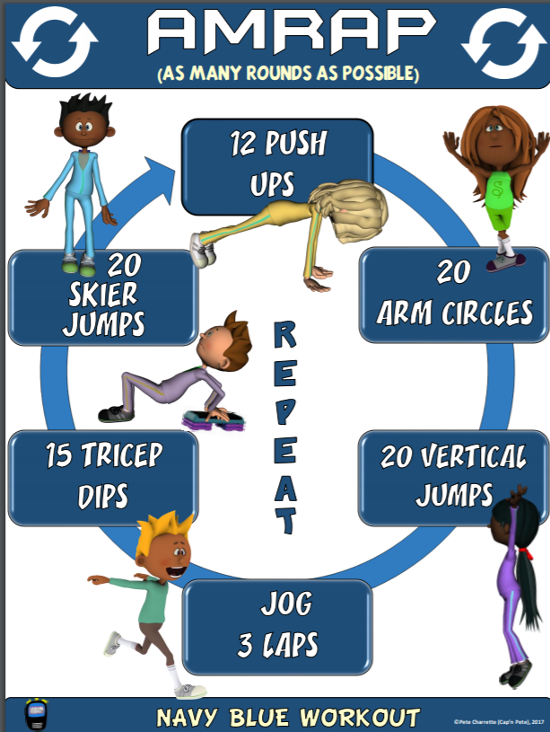

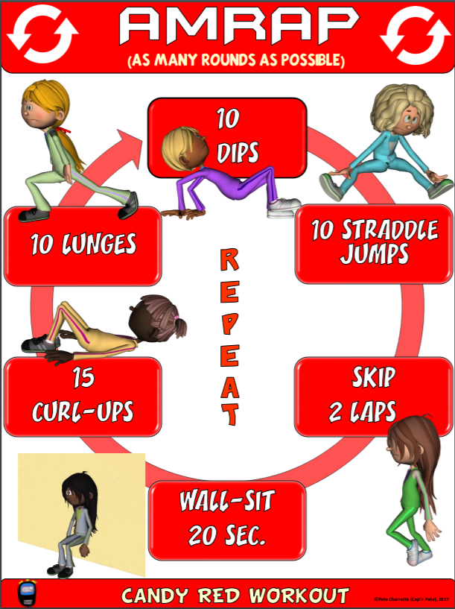

Fidget Spinner P.E. Spin Board #1 and #2
If possible, print the “Fidget Spinner P.E. Spin Board” and place a fidget spinner on the middle of the board. Tape a small arrow to it, spin the fidget spinner and perform the activity that it lands on. You can also use a paper plate if you do not have printer access.

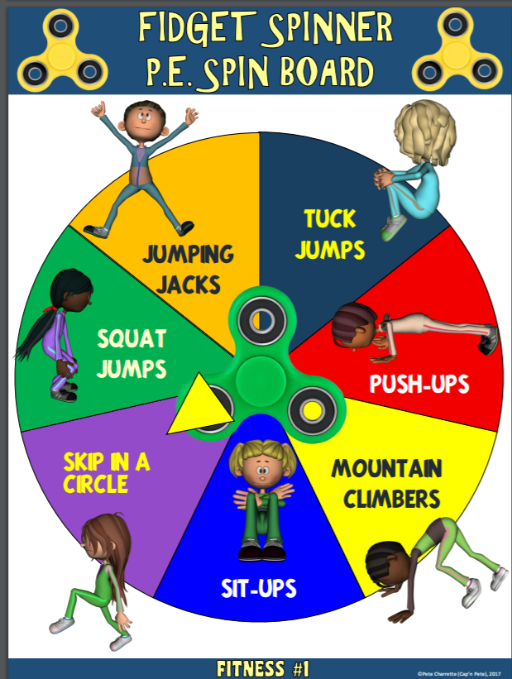

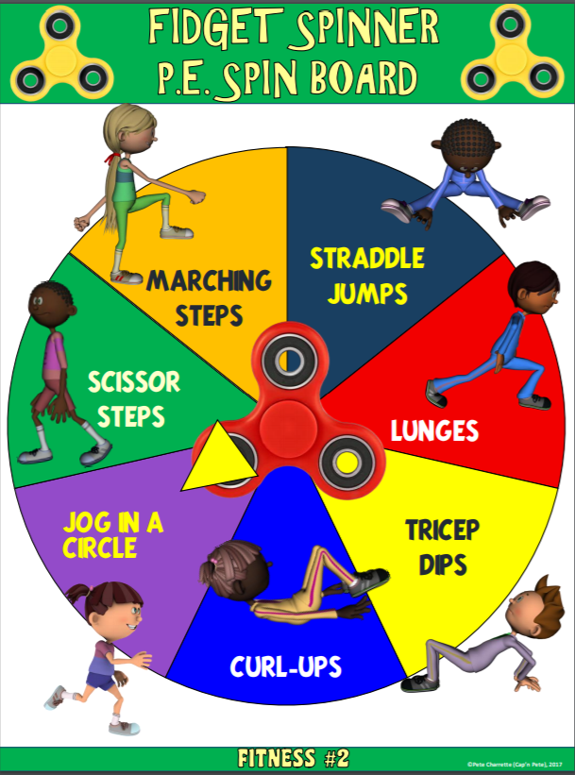

Bean Bag Super Challenge
Perform each challenge using a bean bag, small stuffed animal, or a similar item.
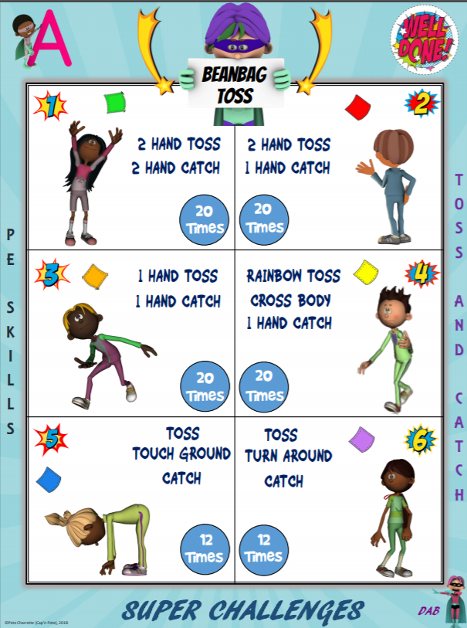

Scarf Super Challenge
Perform each challenge using a scarf or lightweight object that “floats” in the air.
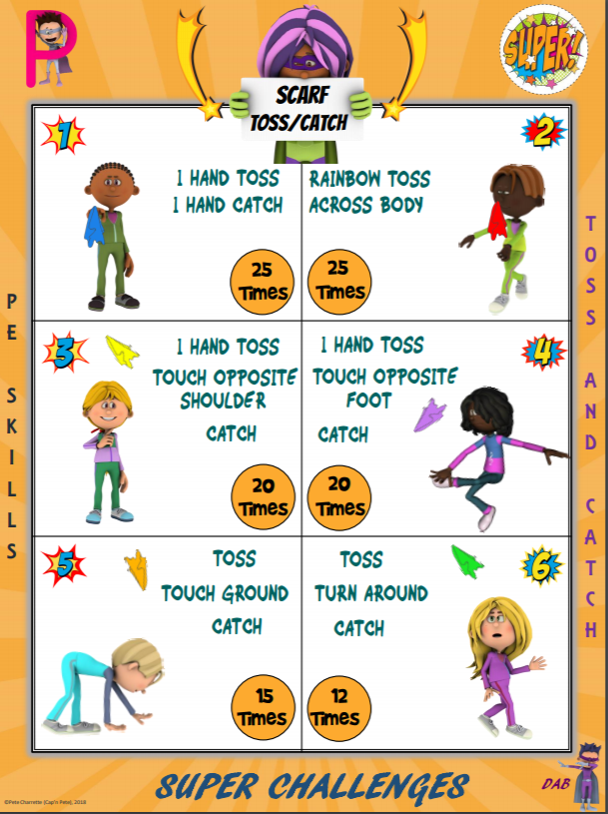
Slam Ball Activity Plan
This game is played similarly to Spike Ball, the activity that we had just finished prior to closure.
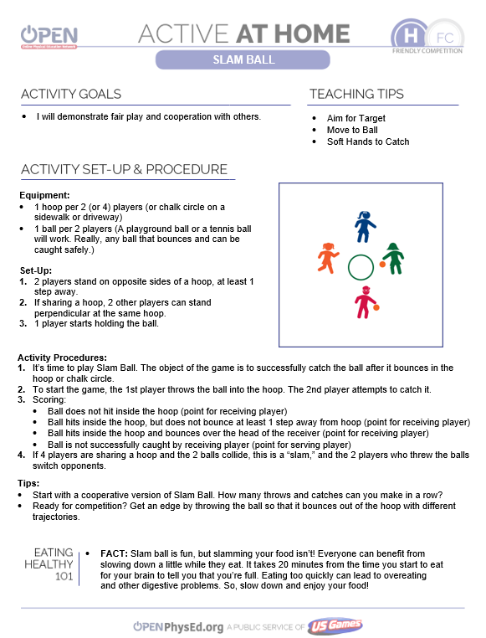

Jump 4 Endurance Rhymes Activity Plan
For this activity, you will need a jump rope and some family members to help.
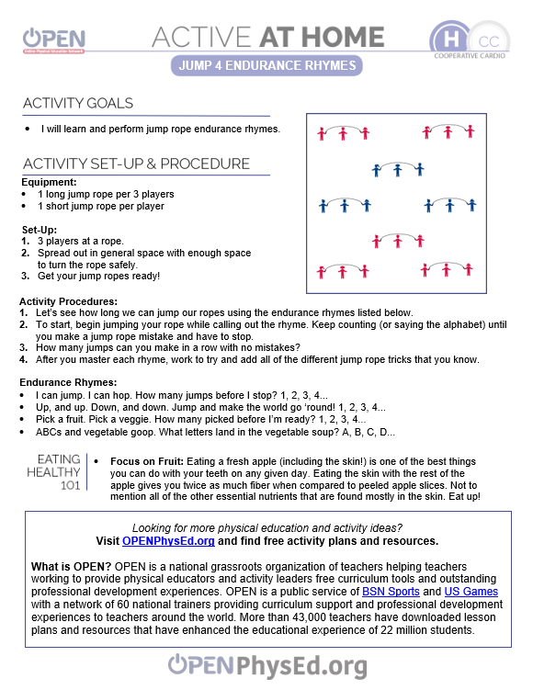

Be Happy Bean Bag Activity Plan
There are many items around your home that can be used for this game.
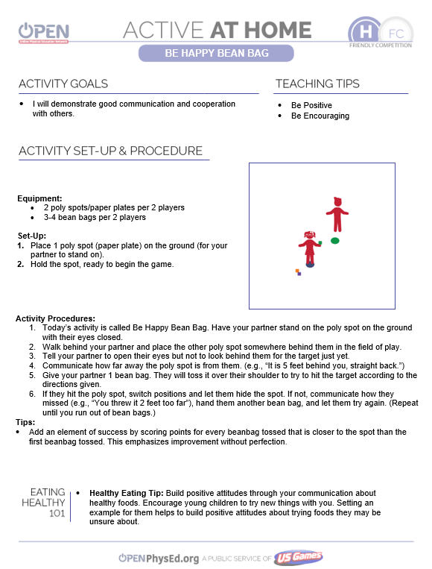

Deck of Fitness Activity Plan
For this activity, you will need a deck of cards and some music.
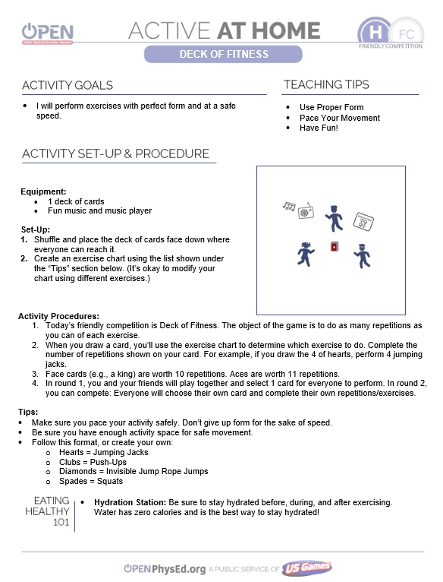

Online Resources

Cosmic Kids Yoga
This link contains child-centered yoga videos that will help your child release some energy while focusing on mindfulness.

Group HIIT Free Kids Workouts
Want to release A LOT of energy, increase your heart rate, while having a great time? Click this link for some great family workout videos.

American Heart Association COVID-19 Resources
This link contains some great ideas for active families as well as some heart healthy recipes using simple ingredients.

