May DEAM Calendar (Drop Everything and Move)
Every day in May, perform or complete the activity of the day. Have a family member sign off on it. It is not a requirement to return this to me, however, if you’d like to share it with me, I would love to hear from you!
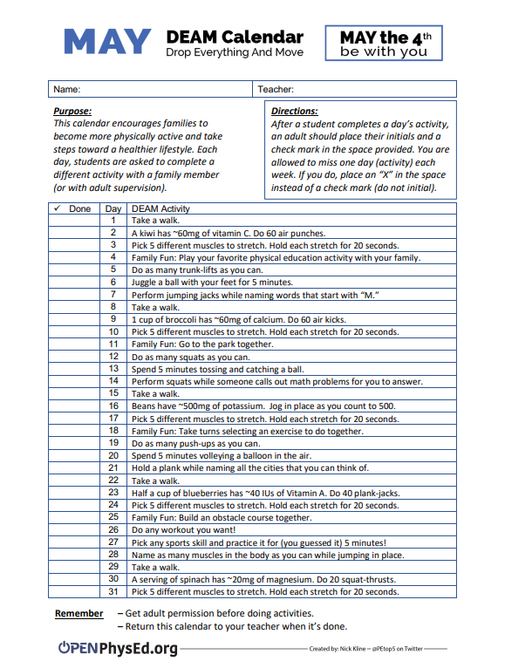
Balloon Striking Challenge
Perform each challenge using a balloon.

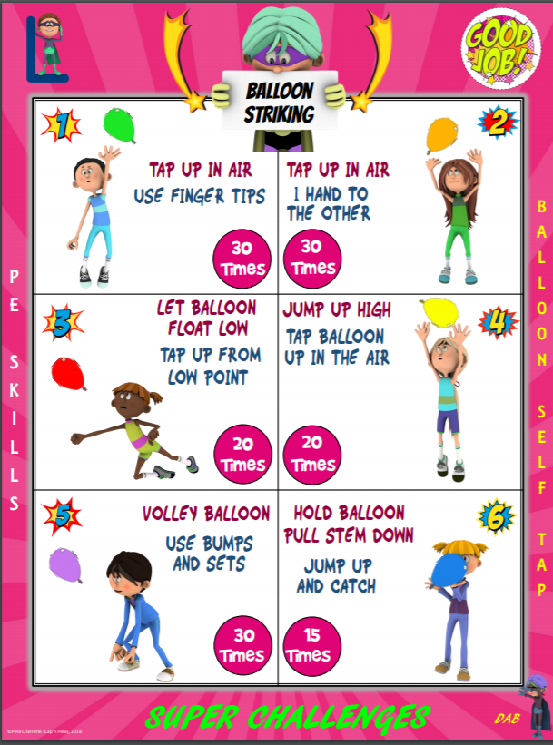
Point Guard Ball Handling
Perform each challenge using a basketball or similar object that bounces.

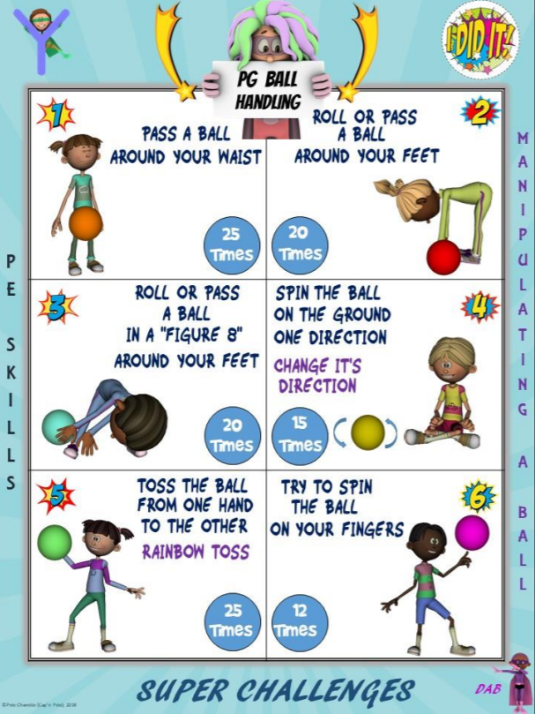
Cup Stacking and Hula Hoop Challenges
Use any kind of cups to try to up-stack and down-stack. Remember, cups with holes in the bottom work better! Make sure you have enough space for the hula hoop challenges.

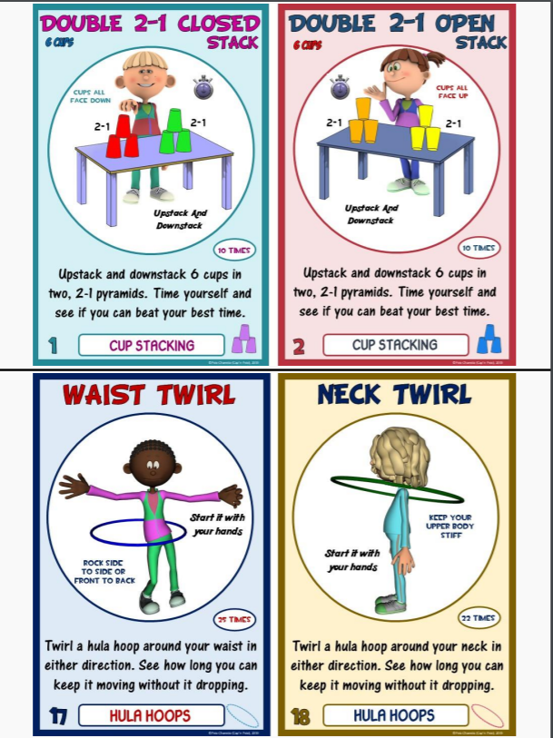

Pool Noodle and Basketball Challenges
Use a small pool noodle to practice your balancing skills. Focus on fast hands for the basketball challenges!

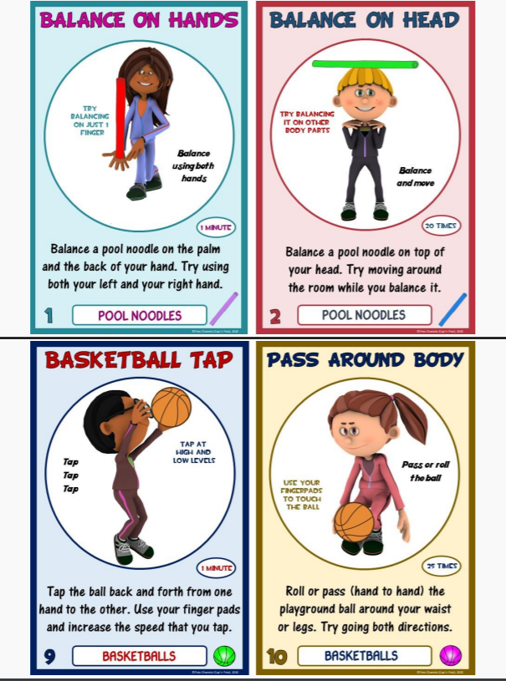
Running Drills
Here you will find some fun running drills to help increase your heart rate. The first time you run them, time yourself. When you do it again, try to beat your first time. Good luck!

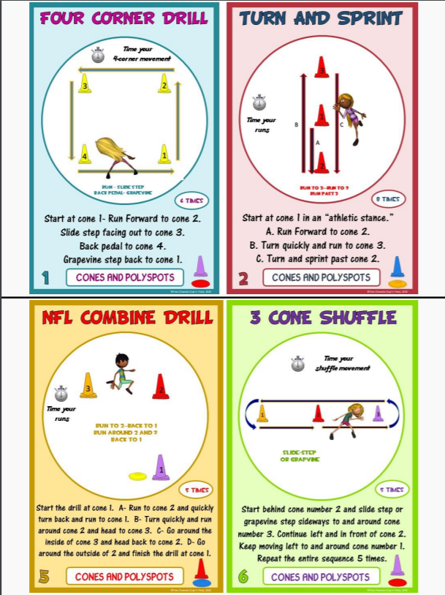
Floss Dance Instructions
Have you always wanted to learn how to “floss”? Here are the instructions! Do you already know how to “floss”? Try to teach someone else in your home! This can also be a good exercise! Challenge someone to see who can do it the longest.

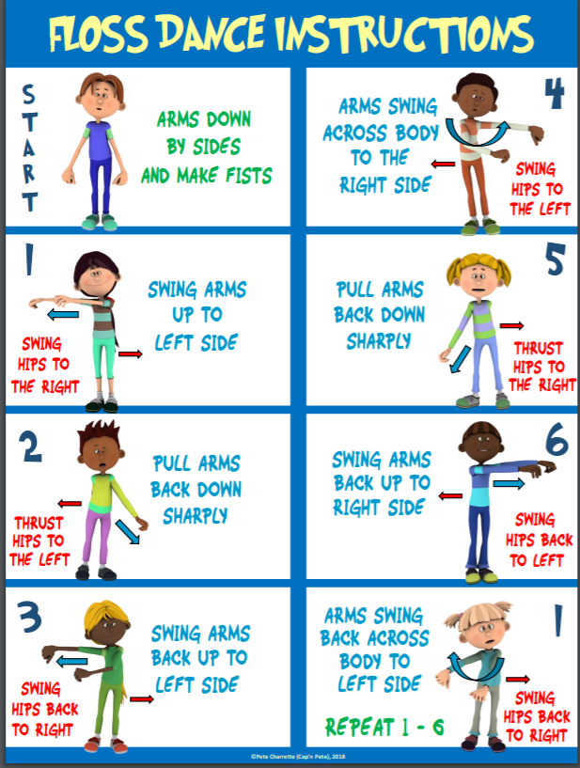
Dice Strength Game
Roll the dice to determine which exercise you will do. Then, roll the dice again and add 3. This is how many repetitions or seconds you will perform the exercise.

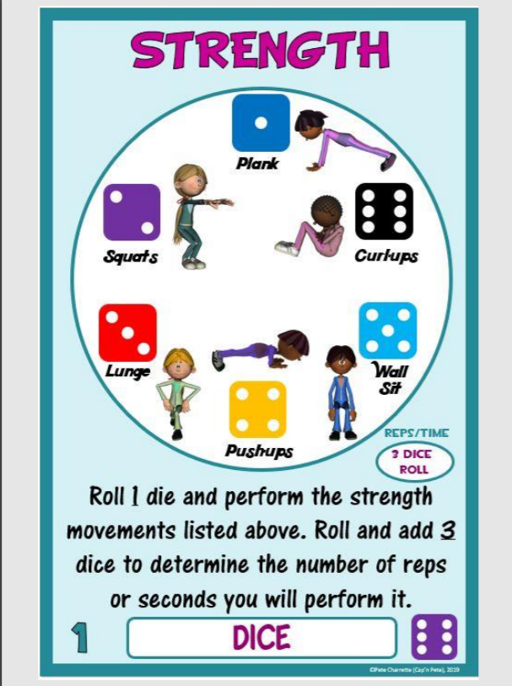
Dice Cardio Game
Roll the dice to determine which exercise you will do. Then, roll the dice again and add 4. This is how many repetitions or seconds you will perform the exercise.

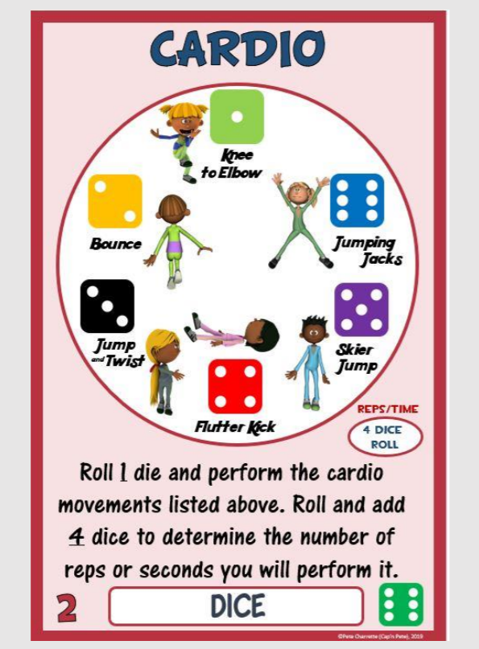
Dice Endurance Game
Roll the dice to determine which exercise you will do. Then, roll the dice again and add 4. This is how many repetitions or seconds you will perform the exercise.

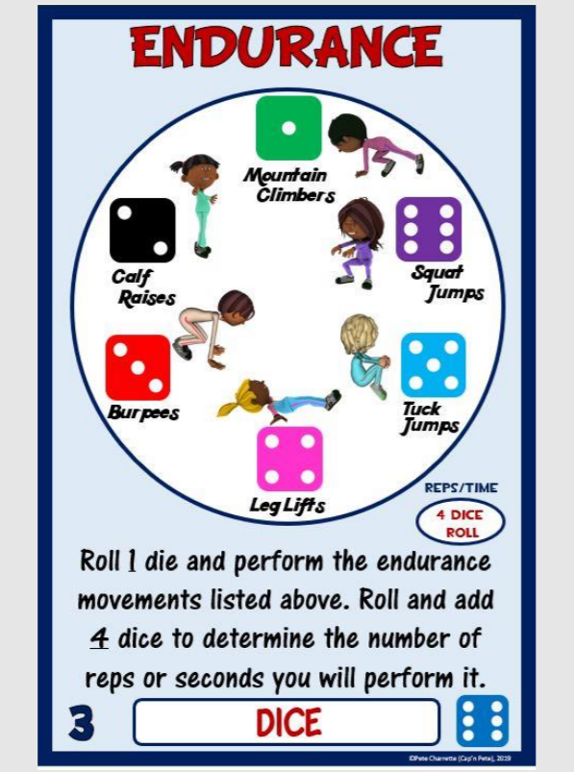

Locomotor Shapes Activity Plan
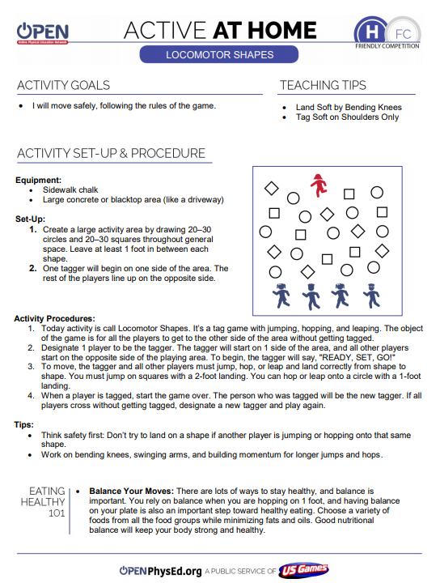

Fun with Scoops Activity Plan
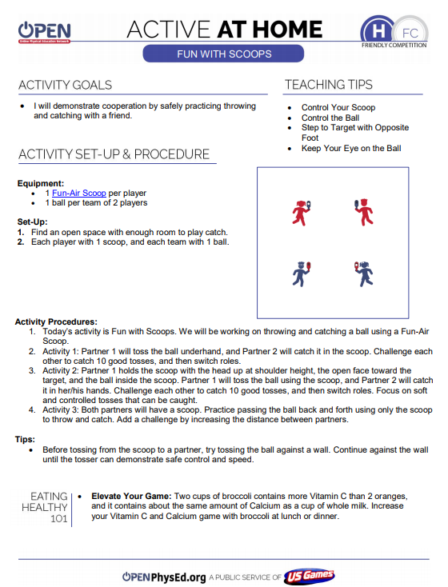

Parachute Pass Activity Plan
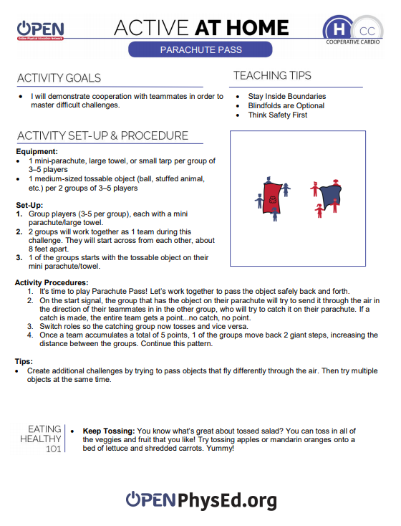
Quick Cuts Activity Plan
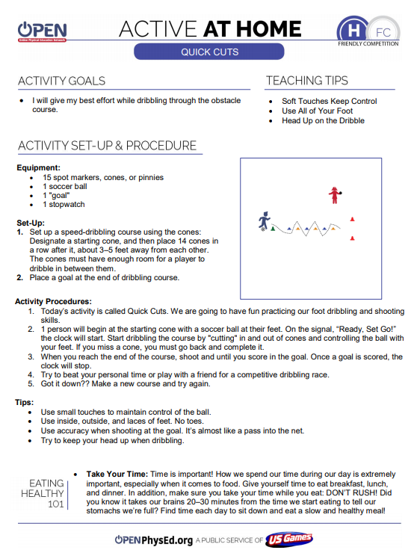

Indoor Scavenger Hunt

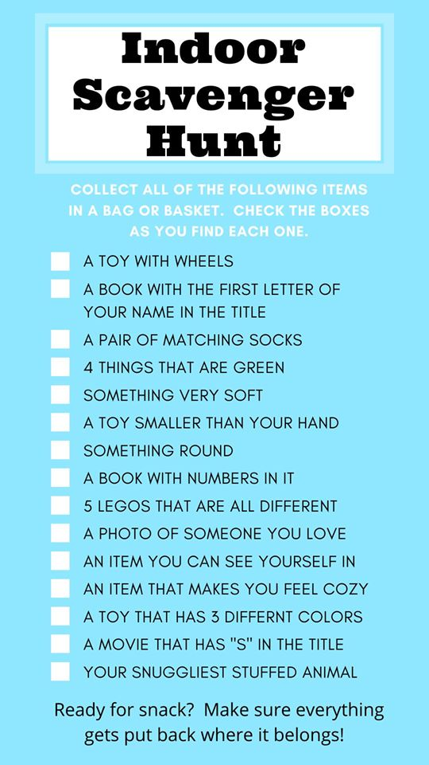
Online Resources

Video Challenges

Bottle Flip Chaos- https://www.youtube.com/watch?v=AZd8oJv6LlM&feature=youtu.be
Fan Favorite- https://www.youtube.com/watch?v=TJuYFFKyoew&feature=youtu.be
Toss & Catch Challenge- https://www.youtube.com/watch?v=fCiATy5gfzc&feature=youtu.be

Guided Lessons

Jumping Rope- https://www.youtube.com/watch?v=D4CXWyFZnaU&feature=youtu.be
1 Minute Fitness Challenges- https://www.youtube.com/watch?v=J0LI2jhlgTA&feature=youtu.be

