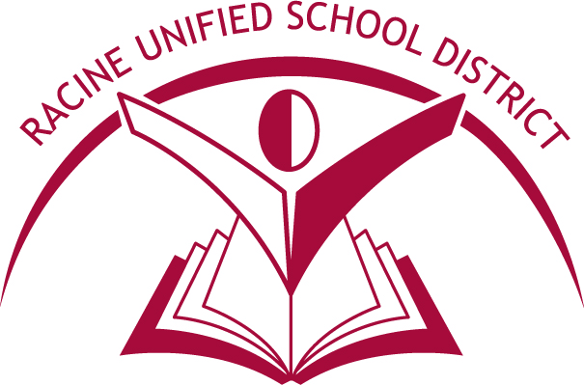
MITCHELL MIDDLE SCHOOL
PARENT INVOLVEMENT

Parents are their child’s first and most important teachers. Therefore, your involvement is the most important part of all Title I Programs. Listed below are nine ways to become involved:

- Attending school parent involvement sessions or sending another family member in your place. Remember, if you need a translator, our district does have a translation service for meetings and phone calls.
- Working with your child on reading/language arts or math activities sent home by the teacher to help you become a partner with the school. We urge you to call us if you have a problem understanding the assignment.
- Meeting with the Title I teacher at Parent-Teacher Conferences or any time you have questions or concerns. Our phone number is 262-664-6400.
- A handbook is sent to you at the beginning of the school year. Keep this handbook as a handy reference guide regarding your child’s Title I Program.
- Read the Title I Literacy Newsletter sent home throughout the school year.
- Remember you can visit your child’s Title I Program as often and whenever you wish, but an appointment should be made with the Title I teacher. Keep in touch with your child’s Title I Literacy and classroom teacher to learn the progress your child is making in school. Reports can easily be sent to you from the Literacy teacher.
- The Title I Program has a Parent District Advisory Council whose membership consists of parent representatives from all of our Title I schools (elementary and middle schools). It meets four times during the school year (October, January, March & May). The meetings are held at the Administrative Service Center. For more information contact Ale Medina at (262) 221-5396 or visit: www.rusd.org/district/title-i.
- The Title I Parent Center, located within Red Apple School, 914 St. Patrick Street is also available for parent use. The Center is open by appointment. The Center provides free materials to support at-home instruction in reading and math; this is a free service to any parent from a Title I school. To make an appointment, please contact Ale Medina at (262) 221-5396.
- At the end of the year, a Parent Survey is done to review the effectiveness of our parent programs. We look at the results as a staff to determine how to make changes to better serve our parents.
- Our Title I parent programs are created many times with the help of PTA, outside organizations and After Zone Programs.

