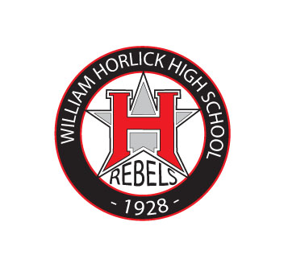

**EARLY RELEASE**

**Block 1:** 7:15 – 8:21 (66 - Class)

**Block 2:** 8:28 – 9:37 (69 - Class/Announcements)

**Block 3-1:** 9:44 – 10:18 (34 - Lunch)

10:18 – 11:26 (68 - Class)

**Block 3-2:** 10:18 – 10:52 (34 - Lunch)

9:44 – 10:18, 10:52 – 11:26 (68 - Class)

**Block 3-3:** 10:52 – 11:26 (34 - Lunch)

9:44 – 10:52 (68 - Class)

**Block 4:** 11:33 – 12:39 (66 - Class)

**REGULAR**

**Block 1:** 7:15 – 8:48 (93 - Class)

**Block 2:** 8:55 – 10:31 (96 - Class/Announcements)

**Block 3-1:** 10:38 – 11:25 (47 - Lunch)

11:25 – 12:59 (94 - Class)

**Block 3-2:** 11:25 – 12:12 (47 - Lunch)

10:38 – 11:25, 12:12 – 12:59 (94 - Class)

**Block 3-3:** 12:12 – 12:59 (47 - Lunch)

10:38 – 12:12 (94 - Class)

**Block 4:** 1:06 – 2:39 (93 - Class)

**ADVISORY\***

**Block 1:** 7:15 – 8:40 (85 - Class)

**Advisory:** 8:47 – 9:19 (32 - Class/Announcements)

**Block 2:** 9:26 – 10:51 (85 – Class)

**Block 3-1:** 10:58 – 11:41 (43 - Lunch)

11:41 – 1:07 (86 - Class)

**Block 3-2:** 11:41 – 12:24 (43 - Lunch)

10:58 – 11:41, 12:24 – 1:07 (86 - Class)

**Block 3-3:** 12:24 – 1:07 (43 - Lunch)

10:58 – 12:24 (86 - Class)

**Block 4:** 1:14 – 2:39 (85 - Class)

*Mondays and Thursdays and as needed

**LATE START**

**Block 1:** 9:15 – 10:21 (66 - Class)

**Block 2:** 10:28 – 11:37 (69 - Class/Announcements)

**Block 3-1:** 11:44 – 12:18 (34 - Lunch)

12:18 – 1:26 (68 - Class)

**Block 3-2:** 12:18 – 12:52 (34 - Lunch)

11:44 – 12:18, 12:52 – 1:26 (68 - Class)

**Block 3-3:** 12:52 – 1:26 (34 - Lunch)

11:44 – 12:52 (68 - Class)

**Block 4:** 1:33 – 2:39 (66 - Class)

**HORLICK HIGH SCHOOL**

**2017 – 2018 Bell Schedule**