# v

**Communication About Student Learning**

**Giese Elementary** School is committed to on-going, two-way and meaningful communication with families, in a language that family members can understand. Some of the ways families, teachers and staff communicate all year are:

* Phone blasts
* Check-in notes/email or phone calls
* Class meetings on understanding student progress
* ClassDojo or Remind App
* The Cheetah Chatter & Classroom Newsletters
* Updates through Infinite Campus Parent Portal: [**www.infinitecampus.com**](http://www.infinitecampus.com)
* Updates on school website: [**https://www.rusd.org/giese/**](https://www.rusd.org/giese/)
* Updates on Facebook page: **https://www.facebook.com/Giese-Elementary-School-1202881499753979/**
* Parent-Teacher Conferences in November and March

**Do you have questions about your child’s progress?**

Contact your child’s teacher by phone (262) 664-8250 or email. Email addresses are listed on the school website at [**https://www.rusd.org/giese/**](https://www.rusd.org/giese/)

**RUSD Parent & Family Engagement District-wide Opportunities**

**RUSD FAMILY RESOURCE CENTER:** The Center offers RUSD families with students attending Title I schools a full range of services and supports to enrich student learning, enrollment in free workshops and certificate training programs, access to community resources, participation in school volunteer opportunities and more. [**https://www.rusd.org/frc**](https://www.rusd.org/frc)

**PARENT LEADERSHIP NETWORK**: An opportunity for parents to receive support and training to serve as school representatives and stay connected to learn about District priorities and ways to participate in the decision-making process. [**https://www.rusd.org/district/parent-leadership-network-0**](https://www.rusd.org/district/parent-leadership-network-0)

**PARENT UNIVERSITY:** A community collaborative of free monthly workshops and information sessions to help parents and caregivers become full partners in their children’s education. The sessions equip parents and caregivers with new or additional skills, knowledge and resources. [**https://www.rusd.org/district/parent-university-0**](https://www.rusd.org/district/parent-university-0)

**FAMILY EMPOWERMENT DAY:**  Saturday, April 13, 2019, 9:00 am – 3:00 pm, Case High School. An annual family fun event for the entire community. This free event offers an enjoyable day of family friendly workshops, early childhood activities, college and community resource fair, free food, giveaways, health screenings and more. Participants have the opportunity to connect with local community partners and agencies. It also features a nationally acclaimed keynote speaker, RUSD student talent and city-wide group performances throughout the entire day. [**https://www.rusd.org/district/2019-family-empowerment-day**](https://www.rusd.org/district/2019-family-empowerment-day)

**PARENT ACADEMY**: This seasonal learning lab promotes hands-on workshops to engage families with students attending Title I schools in exciting ways to support family at home learning time. [**https://www.rusd.org/district/title-i-parent-academy**](https://www.rusd.org/district/title-i-parent-academy)

**WINGS VOLUNTEER:** The District’s WINGS Volunteer Program exists to enhance the educational experiences of students and assist teachers in the classroom. This positive interaction with volunteers often leads to improved self-esteem and academic improvement. In addition, volunteers can help provide a positive environment for students. For more information visit [**www.rusd.org/district/volunteering**](http://www.rusd.org/district/volunteering)**.**

Jointly Developed

The families, students, and staff of Giese Elementary develop this School-Parent Compact. Teacher suggested home learning strategies, families added ideas to make them more specific, and students told us what would help them learn. The Title I Parent Annual Meeting is held every year to review the compact and the changes based on student needs.

**Giese Elementary School**

**5120 Byrd Avenue, Racine, WI 53406**

**(262) 664-8250**

[**https://www.rusd.org/giese/**](https://www.rusd.org/giese/)

**Facebook**

**https://www.facebook.com/Giese-Elementary-School-1202881499753979/**

**Title I Schoolwide Prog­­ram**

**SCHOOL-  
PARENT  
COMPACT**

**A School-Parent Compact** is an agreement between school staff and families which provides an opportunity to strengthen the home-school partnership. It explains how families and the school will work together to share the responsibility for improved student achievement.

.

**Building School-Home Partnerships**

Join us for one of the many fun-filled family events including:

* Holiday Musical Program – December 18, 2018
* Winter Movie Night – February 2019
* Studer Survey Parent Pizza Party – March/April 2019
* Slide into Summer Resource Night – May 2019
* Awards Banquet – June 2019

**Parent/Family Responsibility: At Home Learning Goals - Communication** Schools can plan and conduct workable methods of two-way communication—from school to home and from home to school. Communications, whether to groups or individual families, should focus on the child's learning.

* Schedules parent-teacher-student conferences to monitor student progress at times convenient for parents.
* Informs parents how and when they can reach teachers during and beyond the school surveys, e-mail, comment forms, and others.
* Provides ways for parents to comment on school programs and activities, such as surveys, e-mail, comment forms, and others.
* Provides parents with clear, regular information about children’s progress, including information on testing, report cards, and the curriculum.
* Convenes teachers and support staff to meet with and listen to parents of children with academic or behavior concerns.
* Trains school staff on the value of and need for building effective ties with parents and the community.

|  |  |  |  |  |  |  |  |
| --- | --- | --- | --- | --- | --- | --- | --- |
| Schedules parent-teacher-student conferences to monitor student progress at times convenient for parents. |  |  |  |  |  |  |  |
| Informs parents how and when they can reach teachers during and beyond the school surveys, e-mail, comment forms, and others. |  |  |  |  |  |  |  |
| Provides ways for parents to comment on school programs and activities, such as surveys, e-mail, comment forms, and others. |  |  |  |  |  |  |  |
| Provides parents with clear, regular information about children’s progress, including information on testing, report cards, and the curriculum. |  |  |  |  |  |  |  |
| Develops ways to communicate with parents who do not speak or read English well, including providing translators and videotaped messages. |  |  |  |  |  |  |  |
| Convenes teachers and support staff to meet with and listen to parents of children with academic or behavior concerns. |  |  |  |  |  |  |  |
| Trains school staff on the value of and need for building effective ties with parents and the community. |  |  |  |  |  |  |  |
| "Conducts these activities that research has shown improve children’s learning: (a)  Sponsors orientations for families new to the school (b)  Produces a regular school newsletter and website updates (c)  Has a welcoming environment " |  |  |  |  |  |  |  |
|  |  |  |  |  |  |  |  |
|  |  |  |  |  |  |  |  |
| Builds policies that encourage teachers to communicate frequently with parents about the curriculum, homework expectations, and how parents can help. |  |  |  |  |  |  |  |

**Ensure experiences, opportunities and choice so every RUSD student is academically, socially and emotionally successful and ready for career and/or college**

**School Responsibility: Student Achievement Goals**

**Reading Goal: To increase the percent of students at or above college/career readiness by 10% moving from 22% of students at or above grade level NWEA MAP benchmarks to 32% at or above grade level NWEA MAP benchmarks by the end of the school year.**

**Math Goal: To increase the percent of students at or above college/career readiness by 10% moving from 20.8% of students at or above grade level NWEA MAP benchmarks to 30.8% at or above grade level NWEA MAP benchmarks by the end of the school year.**

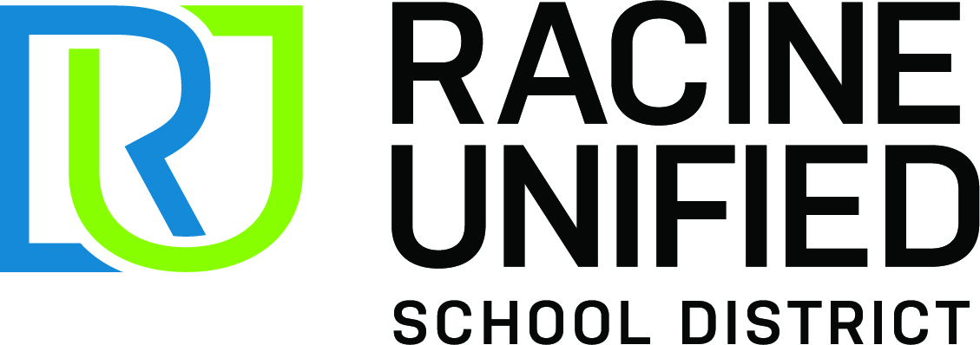

**RAISING RACINE 2022**

Ensure experiences, opportunities and choice so every RUSD student is academically, socially and emotionally successful and ready for career and/or college.

**Four-year graduation rate from 76.8% to meet or exceed state average by 2022.**

**ACT: Eleventh grade students at or above the CCR Benchmark:**

• Math: from 15.2% to 25.2%

• Reading: from 21.4% to 31.4%

**Ninth grade students earning 7 high school credits (including math-Algebra 1 or higher) from 60.5% to 80%.**

**Forward Exam: 7th grade students scoring proficient/advanced increased by 15%:**

• Math: from 12.6% to 27.6%

• ELA: from 20.4% to 35.4%

**MAP at the CCR Benchmark increase by 15%:**

• 3rd grade students reading from 23.5% to 38.5%

• 5th grade students math from 23.7% to 38.7%

**Title I Schoolwide Program**

Title I is a federal program that provides funds to school districts and schools with high numbers or high percentages of disadvantaged children. Its overall purpose is to ensure that all children have a fair, equal and significant opportunity to obtain a high-quality education and reach, at a minimum, proficiency on challenging state academic achievement standards and assessments.

**Schoolwide programs serve all children in a school.** All staff, resources, and classes are part of the overall Schoolwide program. The purpose is to generate high levels of academic achievement in core subject areas for all students, especially those students most in need. This purpose is achieved through high quality instruction, comprehensive reform strategies and methods that are based on the use of scientifically based research, strategies and methods to improve teacher quality and professional development and consolidated use of funds.

**School staff and families *share* the responsibility for learning!**