Walden T-Shirts For Sale

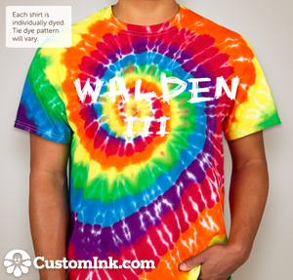

Shirts will be available at
Family Night.

$15.00 each.

If you are unable to come to family night and would like a t-shirt email me kleslie001@wi.r.com.

