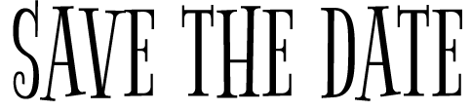

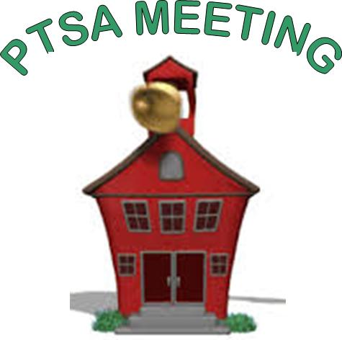
Come join us at the
ptsa meetings!
Thursdays at 5:30pm in the School Library
Meet other parents, talk to administrators, hear from special speakers, and find out what’s going on at McKinley!
September 24
November 12 (5:00pm – 6:00pm)
January 14
March 10
May 12

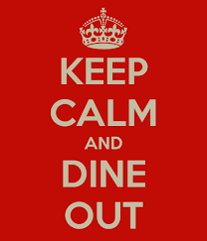

Dine outs!
Leave the cooking to us…
and earn money for McKinley!

Thursday, September 17 | Noodles & Company | 4:00pm – 10:00pm
Tuesday, October 6 | Chick-Fil-A | 4:00pm – 8:00pm
Thursday, October 22 | Georgie Porgies | 4:00pm – 9:00pm
Wednesday, November 4 | Buffalo Wild Wings | 11:00am – close
Thursday, November 19 | Noodles & Company | 4:00pm – 10:00pm
Tuesday, December 1 | Chick-Fil-A | 4:00pm – 8:00pm
Thursday, December 17 | Georgie Porgies | 4:00pm – 9:00pm
Wednesday, January 13 | Buffalo Wild Wings | 11:00am – close
Be sure to visit the school website for more information!

