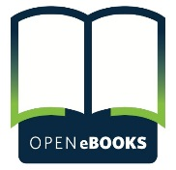
HELPING ALL CHILDREN DISCOVER A LOVE OF READING

Open eBooks is an app containing thousands of popular and award-winning titles that are free for children from low-income households. These eBooks can be read without checkouts or holds. Children from low-income families can access these eBooks, which include some of the most popular works of the present and past, using the Open eBooks app and read as many as they like without incurring any costs. The goal of Open eBooks is to encourage a love of reading and serve as a gateway to children reading even more often, whether in school, at libraries, or through other eBook reading apps.
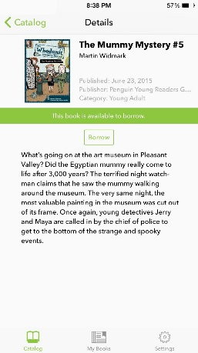
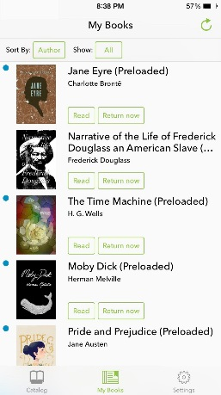
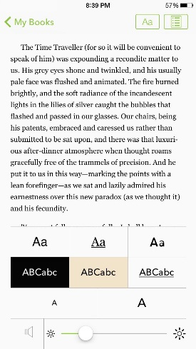
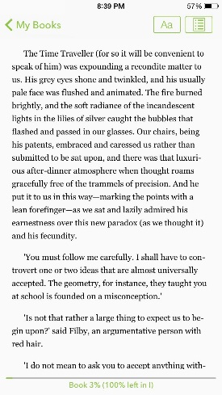

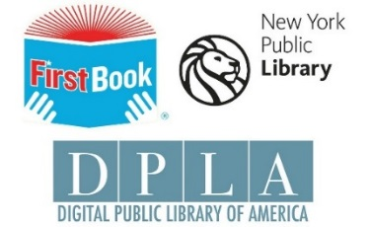
A coalition of literacy, library, and publishing partners joined the White House to make the Open eBooks program possible. The Initiative partners, Digital Public Library of America (DPLA), First Book, and The New York Public Library (NYPL), created the app, curated the eBook collection, and developed a system for distribution and use. They received financial support from the Institute of Museum and Library Services (IMLS), eBook contributions from major publishers and digital content distribution services donated by Baker & Taylor.
How does Open eBooks relate to other projects that provide access to eBooks?
The Open eBooks initiative is intended to complement other existing free eBook/reading projects, as well as the services of public libraries across the country. In contrast to several other projects, it makes current, trending books available from the publishers rather than relying solely on public domain works.

How does it work?

Adults who work with children in need through libraries, schools, shelters and clinics, out-of-school programs, military family programs, early childhood programs, and other capacities can qualify for credentials for Open eBooks by first signing up with First Book. Once signed up with First Book, these educators can request Open eBooks access for the children they serve. Students can download the app to their individual devices and enter their access code to start enjoying Open eBooks. Children in need will have unlimited access to titles in the app.

What platforms will the Open eBooks app be available on?

Initially the app will be available on iOS and Android and will be available to download from the App Store or Google Play, respectively. Subsequent versions of Open eBooks will be optimized to support as many open platforms as possible. The Open eBooks app uses next generation eBook technology to make reading on your smartphone or tablet simple and convenient. It is designed to make browsing, accessing, and reading eBooks simple and easy.

How to Install
- You will need an Apple ID and a device with iOS8 or above in order to download the Open eBooks app.
- From the Apple App Store app, search for and install the free Open eBooks app. Once installed, open the Open eBooks app.
- Tap Accept to agree to the terms of Service
- To register your First Book code
  - At the bottom of the screen, tap Settings > Account and enter your Access Code and PIN.
  - Tap Log In.

Browsing the Collection
- Tap the Catalog icon (open book) at the bottom of the screen. At any time you can tap the cover of the book to read a description of the book and borrow the book.
- Browse Categories:
  - Swipe from left to right on the book covers to view the popular and available for the respective category.
  - Scroll up and down to view the different categories.
  - Tap the category titles or More... to view sub categories or a list of all books in the respective category.
- Browse Category List:
  - Scroll up and down to browse the list of books

To Find a Title
- To search for a particular title
  - Tap the Search icon (magnifying glass) in the navigation bar in the upper right corner of the screen.
  - Type the name of the author or title of the book. A list of books matching your search criteria will be displayed.
  - Scroll the list of results to find your book or refine your search.

Reading an eBook
- At any time you can tap the cover of a book and tap Borrow to get the book. When the books has downloaded to your device you simply tap Read to open and read the eBook
- To exit or navigate to a particular section
  - Tap the center of the screen to bring up the top menu bar.
  - Tap My Books on the upper left to exit the book
  - Tap the button on the upper right of the top menu bar to bring up the TOC (table of contents), then tap on the section or chapter you wish to open.
- To change font type, size, contrast or brightness
  - Tap the center of the screen to bring up the top menu bar.
  - Tap the button (second from the right of the top bar menu).
  - Tap the appropriate control or selection from the options displayed.

Accessing your Bookshelf
- Tap the My Books icon in the bottom center of the screen.
  - Tap Read to open and read a particular book.
  - To turn the page, tap on the left or right edges of the screen.

On your Android Device

How to Install
- You will need a Google Play account. From the Google Play Store app, search for and install the Open eBooks app.
- Once installed, open the Open eBooks app.
- Tap Accept to agree to the terms of Service
- To register your First Book code:
  - Tap Settings > Account and enter your Access Code and PIN
  - Tap Log In.

Browsing the Collection
- Tap the icon at the top to open up the menu. Select catalog and the browse lanes will appear. At any time you can tap the cover of the book to read a description about the book, download, checkout or place a hold on the book.
- Browse Categories:
  - Swipe from left to right on the book covers to view the popular and available for the respective category.
  - Scroll up and down to view the different categories.
  - Tap the category titles or More... to view sub categories or a list of all books in the respective category.
- Browse Category List:
  - Scroll up and down to browse the list of books

To Find a Title
- To search for a particular title
  - Tap the Search icon (magnifying glass) in the navigation bar in the upper right corner of the screen.
  - Type the name of the author or title of the book. A list of books matching your search criteria will be displayed.
  - Scroll the list of results to find your book or refine your search.

Reading an eBook
- At any time you can tap the cover of a book and tap Borrow to get the book. When the book has downloaded to your device you simply tap Read to open and read the eBook
- Tap Read to open and read the book.
- To turn the page, tap on the edges of the screen.
- To exit or navigate to a particular section
  - Tap the center of the screen to bring up the top menu bar.
  - Tap the My Books on the upper left to exit the book
  - Tap the Menu button on the upper right of the top menu bar to bring up the table of contents, then tap on the section or chapter you which to open.
- To change font type, size, contrast or brightness
  - Tap the center of the screen to bring up the top menu bar.
  - Tap the A button (second from the right of the top bar menu).
  - Tap the appropriate control or selection from the options displayed.

Sort Book Lists
- At the list level, tap on Author to change the sort order.
  - Tap Title to sort by title or
  - Tap Author to continue to sort by author

Approaching the Maximum Number of eBooks
- Open eBooks users can borrow up to 10 books at once.
- How to know how many eBooks you currently have borrowed
  - Tap the My Books icon at the bottom center of the navigation screen. The list of books you currently have borrowed will appear.
- Tap Return to return the books
- Returning one or more eBooks will allow you to borrow new titles.
- There is no limit to how many times you can borrow a single title.

